Collaboration policy: This is an assignment to be completed individually. General discussion among students in this class and elsewhere, about how to use Java, how to create zip files, etc. are acceptable. But no discussion/sharing of how to solve the problem is allowed. No internet or other searching or asking for solutions is allowed. You may post general questions, but no code, to Slack. Questions asking for clarification of the specifics of the problem are allowed.

Sentiment Analysis is a Data Science problem which seeks to determine the general attitude of a writer given some text they have written. For instance, in movie reviews we would like to have a program that could look at the text “The film was a breath of fresh air” and realize that it was a positive statement while “It made me want to poke out my eye balls” is negative.

One algorithm that we can use for this is to assign a numeric value to any given word based on how positive or negative that word is and then score the statement based on the values of the words. But, how do we come up with our word scores in the first place?

That’s the problem that we’ll solve in this assignment. You are going to search through a file containing movie reviews from the Rotten Tomatoes website which have both a numeric score as well as text. You’ll use this to learn which words are positive and which are negative. The data file looks like this:

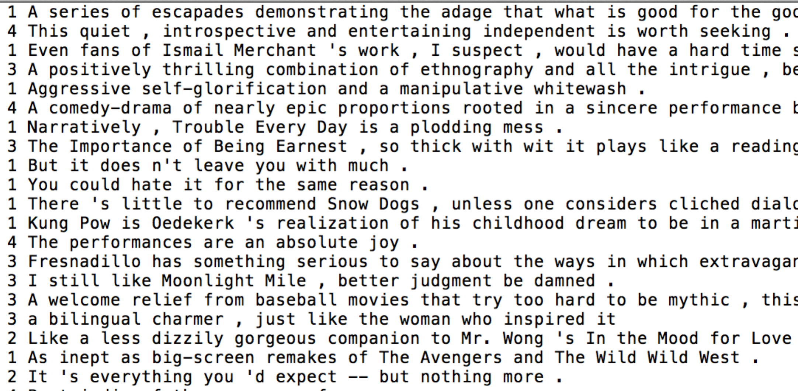

Note that each review starts with a number 0 through 4 with the following meaning:
- 0 : negative
- 1 : somewhat negative
- 2 : neutral
- 3 : somewhat positive
- 4 : positive

1. (30 points) For the base assignment, you will ask the user to enter a word, and then you will search every movie review for that word. If you find it, add the score for that review to the word’s running score total (i.e., an accumulator variable). You also will need to keep track of how many appearances the word made so that you can report the average score of reviews containing that word back to the user. (Note, averages are real numbers, not integers.)

Some sample runs of the program might look like this (although the values shown might not be exact):
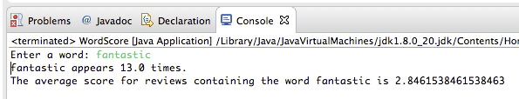

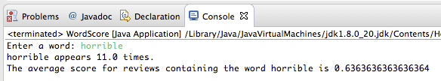

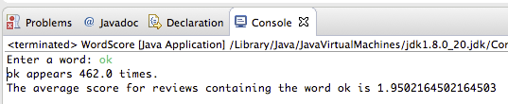

Note that as you search through the lines of text in the file, since the number and the text appear on the same line, you can get them both with statements like
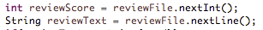
This is a case where eating the leftover newline character after a number would be a bad idea because the rest of the line contains the review text.

Note also that you can check if a string contains another string as a substring using the .contains() String method. If reviewText is the variable containing the whole review, and word is the variable containing the word that the user is asking about, then you might check if the review has that word in it, with a statement like this:

The provided starter code currently asks the user for a word, and reads through the file and displays the numeric rating and textual review for movies containing that word. Modify the program to accomplish the rest of what is described above.

2. (10 points) Ask the user to give you the name of a file containing a series of words, one-per-line, and compute the score of every word in the file. Report back to the user the average score of the words in the file. This will allow you to predict the overall sentiment of the phrase represented by words in the file. Consider an average word score above 2.01 as an overall positive sentiment and consider average score below 1.99 to have an overall negative sentiment. As an example, for a file called negTest.txt containing words like this:
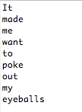
A sample run might look like this:

3. (10 points) Ask the user to give you the name of a file containing a series of words, one-per-line, and compute the score of every word in the file. Report back to the user which word was the most positive and which was the most negative. An example run might look like this
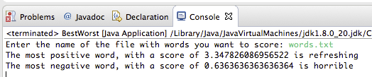

for a file that looks like this:
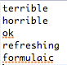

4. (10 points) Create a menu that allows the user to pick the functionality that they want from the choices. When finished with it, present the menu again until the user chooses to exit. A sample run of the menu might look like this. (Note that the menu also includes the bonus option, discussed next.) (Note that item 4 is for the optional bonus. Please include 4 in your menu, but it is ok that a request for 4 does nothing.) The user should be forced to enter a valid number: 1-5.
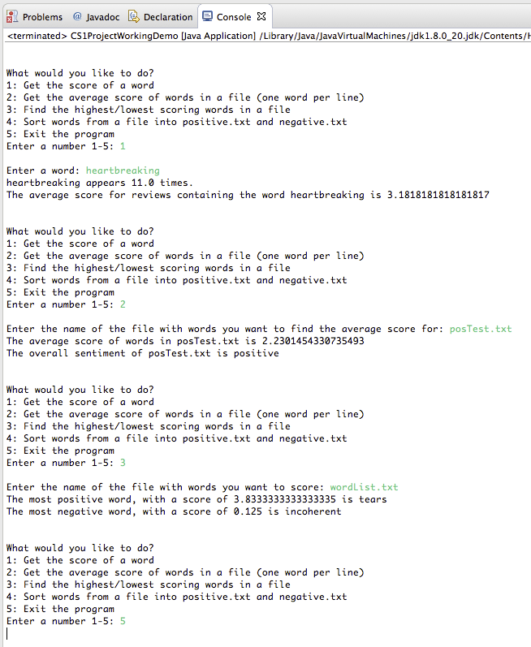
5. (BONUS 10 points) Add functionality that will ask the user to enter a word file like in the previous step, but instead of reporting the best and the worst word, create two files called positive.txt and negative.txt, sorting words that have scores below 1.9 into negative.txt, and words that have scores above 2.1 into positive.txt (and just leave out words in between).

Program Submission
Create a ZIP file that only contains .java files and txt files (no other files types). DO NOT include a file hierarchy (i.e. the package structure) – just one or more .java files. For the ZIP file you must use the naming convention: <Lastname><Firstinitial>.zip e.g., StalveyR.zip If the assignment is not submitted in the correct format – it will not be graded – no exceptions! Submit the ZIP file via OAKS in the Dropbox that corresponds to the assignment. Resubmit as many times as you like, the newest submission will be the graded submission.

Note – to create such a zip folder:
- Create an empty folder with the name <Lastname><Firstinitial>
- Move your HW1.java file and any text files into it.
- Zip/compress it into <Lastname><Firstinitial>.zip
- Upload to OAKS.

To test if you have created a proper submission file, assuming your name is Hans Nero:
- Unzip NeroH.zip
- You should now see a folder named NeroH
- Look in NeroH and see ONLY java and text files you wish to submit.
- If 1, 2, & 3 succeeded, success! Submit NeroH.zip

Grading Rubric
20 Points | Style: Comments, Indentation, meaningful naming, efficient algorithm, etc.
80 Points | Functionality:  - Program compiles (10)  - Program runs (10)  - For given inputs (Numbers 1-4), program produces correct output (60)
- If the submitted program does not compile: 0 of 80 points
- If the submitted program compiles but does not run: 10 of 80 points
- If the submitted program compiles and runs: 20 of 80 points
- If the submitted program compiles, runs, and produces correct output: 80 of 80 points
The correctness of your program will be evaluated using test cases developed by the instructor.

Late assignments will not be accepted – no exceptions (please do not email me your assignment after the due date, I will ignore it).

Please feel free to setup an appointment or drop by during office hours to discuss the assigned problem. I’ll be more than happy to listen to your approach and make suggestions.

---

Required program documentation:
Header comments at the start of each file must include:
Your name
HW #, Summer 2021
A one- to three-sentence description of the purpose of the code in this file.
For any file that you edit or write, include a comment describing how you completed the file. Here are some examples:
This work is entirely my own.
This code was written by me alone, but I did discuss the problem with XXX and YYY.
This code was written by me alone, but I did discuss the problem with tutors at the Center for Student Learning.

// Note: you do not have to document that you talked to the instructor or the TA.

